Campus Party Europe in London 2-7 September 2013
Venue: The O2 in London
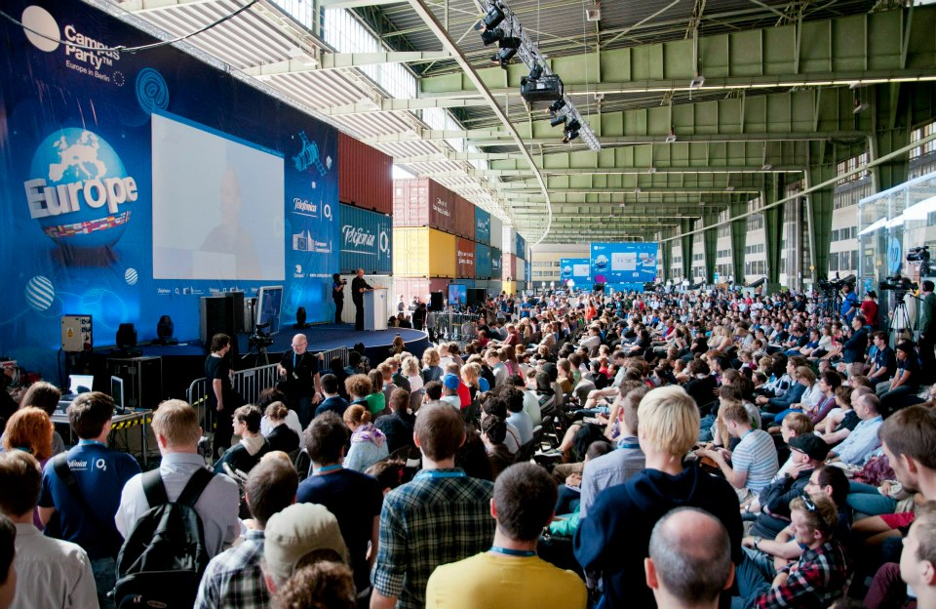

- Line-up will include inspirational talks from the world's best science and technology leaders and exclusive live acts
- Campus Party Europe will bring together over 10,000 of Europe’s digitally minded
- The week-long, 24/7 event includes the world’s first digital skills market place

Campus Party Europe, one of the world’s biggest and most ambitious tech festivals, comes to The O2 in London, UK, from the 2nd till the 7th September 2013. The unique event will excite 10,000 young people per day across Europe about the possibilities of new and emerging technology, and will inspire a generation of young people to become digital makers and help create new pathways into digital careers.

In contrast to other technology events, Campus Party is aimed at people interested in digital technology and how it is helping to define and shape modern culture and society, as well as, techpreneurs, hackers, developers, gamers and geeks. A massive digital skills marketplace will sit at the heart of the festival alongside 8 stages, over 100 speakers and over 500 hours of content across five action-packed days.

Ronan Dunne, CEO of Telefónica UK, said: “Since 1997 tech fans across Europe and Latin America have flocked to Campus Party in their thousands to innovate, learn and engage with some of the biggest names in technology. This year we’re injecting even more ambition and more scale into an already huge event.

Dunne continued: “The marketplace will feature a huge range of free support services, including advice on how to get your foot on the career ladder or how a business can succeed on Facebook. The event will help people hone and develop their digital skills whilst giving businesses of all sizes the opportunity to find the talent they need to grow.”

The festival will feature some of the world’s most inspirational science and technology communicators who will be set the challenge of debating the biggest issues impacting our shared digital future.

Speakers at previous Campus Party events include Tim Berners-Lee, the inventor of the World Wide Web; Steve Wozniak, co-founder of Apple; and astronaut Neil Armstrong. The full line-up for Campus Party 2013 will be announced soon.

Dunne concluded: “Whether you are looking for an opportunity in tech, a fledgling start-up, an established enterprise or simply interested in finding out how new technology is shaping our world, you’ll find something to excite and inspire you at Campus Party.”

Tech communities are an important part of Campus Party as it allows tech lovers from all over the globe a chance to meet each other in a single forum to innovate, learn and discuss the digital future.

Find out more information or pre-register at http://www.campus-party.eu/

Businesses and educational organisations keen be at the Digital Skills Marketplace can email campusparty@telefonica.com for more information.

