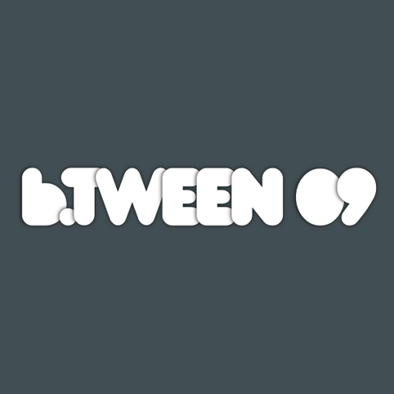
Press Release
Immediate release
4 June 2009

b.TWEEN: a conference across 3 cities.
Live webcasts and chat from independent
cinemas provide a truly interactive forum

b.TWEEN interactive digital media forum brings together a host of digital pioneers and thought leaders from TV, advertising, web and social networks. This year includes a keynote from the hugely influential Charles Leadbeater and speakers from Spotify, Channel 4, Bebo, Ogilvy and TateMedia to name but a few. The 2 day event takes place at FACT, Liverpool, 11 – 12 June.

Live interactive webcasts in Manchester and Bristol shape conference content
b.TWEEN is pleased to announce it will take conference broadcasting and audience engagement to a whole new level, not only will a packed house watch and engage with the conference at FACT but audiences in Bristol will be able to enjoy the event from the Watershed and from Cornerhouse in Manchester too. The ‘remote’ audiences can also ask questions direct through a live chat system and help shape the conference live from miles away.

This project is being piloted as part of the Mixed Artform Venues programme of activity – this is a new UKFilm Council funded collaboration between venues across the UK including Watershed, Cornerhouse, Broadway, Showroom and Tyneside. The event will be a first for the venues involved – helping to redefine what independent cinema can deliver.

Conference highlights available in all of the venues include:

Manifesto for Mutual Media – Keynote by Charles Leadbeater
A short, powerful presentation by a man who, as well as advising a wide range of organisations on innovation including the BBC, Vodafone, Microsoft, Ericsson, Channel Four Television and the Royal Shakespeare Company, has been an ideas generator in his own right. As an associate editor of the Independent he helped Helen Fielding devise Bridget Jones's diary. He wrote the first British report on the rise of social entrepreneurship, which has since become a global movement. Charles has worked extensively as a senior adviser to the governments over the past decade. He is also a visiting senior fellow at NESTA and a longstanding senior research associate with the influential London think-tank Demos and a visiting fellow at Oxford University's Said Business School. Charles spent ten years working for the Financial Times where he was most recently Features Editor.

Charles will show how concepts of New Media are dead by exploring new behaviours, languages and paradigms evolving around mutual media on social platforms.

Brand Grenades, Sacred Cows
This panel will kick some sacred cows and lob a few brand grenades at some of the myths that have sprung up around the Holy Grail of Branded Content. Guest speakers Michael Bayler, Thomas Benski (Pulse), Jamie Conygham (Dojo Games), Morgan Holt (HUGE).

Mark Earls Keynote ‘Being Human’
HERDmeister, HERD
Earls gives the lowdown on human behaviour from various scientific perspectives. Far from being the thinking, calculating, independent creatures that classical economics would like us to be, we humans are much smarter than that: we are 'super social apes' essentially – as creatures we tend to ‘herd’. Mark highlights some insights and raises some questions for the rest of us.

Telling Tales
A new wave of storytellers has ripped up the storybook and is exploring what new narratives might look like across a distributed landscape. These four speakers come from very different backgrounds, bridging the gap between commercial and creative narratives, and tell their stories in very different ways. Guest speakers include Brad King (Ball State University), Alfie Dennen (Agit8), Alex Fleetwood (Hide&Seek) and Kelly Sweeney (Bebo).

When Dinosaurs Ruled The Earth session sponsored by the Guardian
Our big established cultural institutions - museums, art galleries, libraries and archives - have spent centuries developing the ways in which they allow public access to collections. Now they are re-inventing everything - from how they interact with the public to how they organise their collections, conduct research and manage their teams. Find out how some of the leading edge practitioners are wrestling with the big questions of how to develop the software, digital architecture, tools, partnerships - and rights management - they need to survive and prosper in the new world. The panel includes Peter Buckingham (UK Film Council), John Newbigin, Will Gompertz (Tate Media) and Jane Finnis (Culture 24).

Boom & Bust 2.0? – the impact and future of social networks
The race is on to grow the most populated, frenetic, loyal online network - and investors are piling in funds to support the race. The session will explore how, and if, new entrants - including brands and traditional media - should engage with social media. Guests include Jon Mitchell (Spotify), Michael Nutley (New Media Age), William Owen (MadebyMany) and Giles Rhys-Jones (Ogilvy).

- ENDS -

The live webcast will take place throughout the two-day conference at Bristol’s Watershed and Cornerhouse, Manchester will webcast on the mornings of 11th and 12th June.

Katz Kiely, b.TWEEN Director is available for interview and a number of our guest speakers are also available.

Further information available from btween.co.uk
or call Jo Wingate tel. 0771 5488719
or Kirsty Young tel. 0114 221 0248 email kirsty@just-b.com

